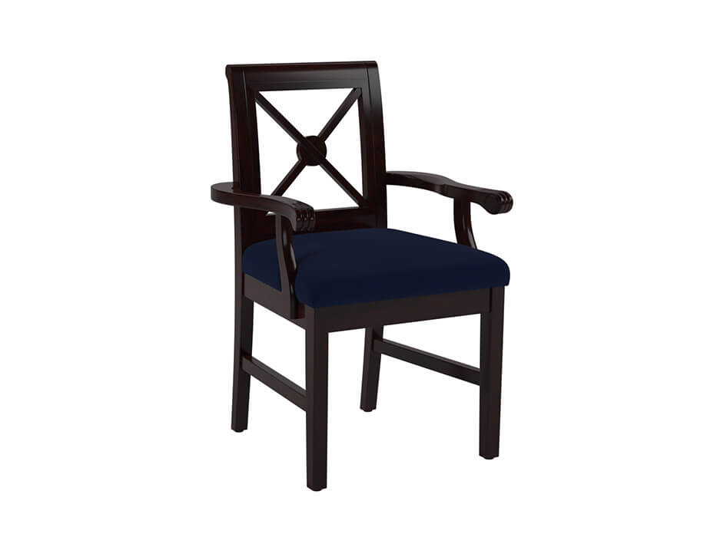 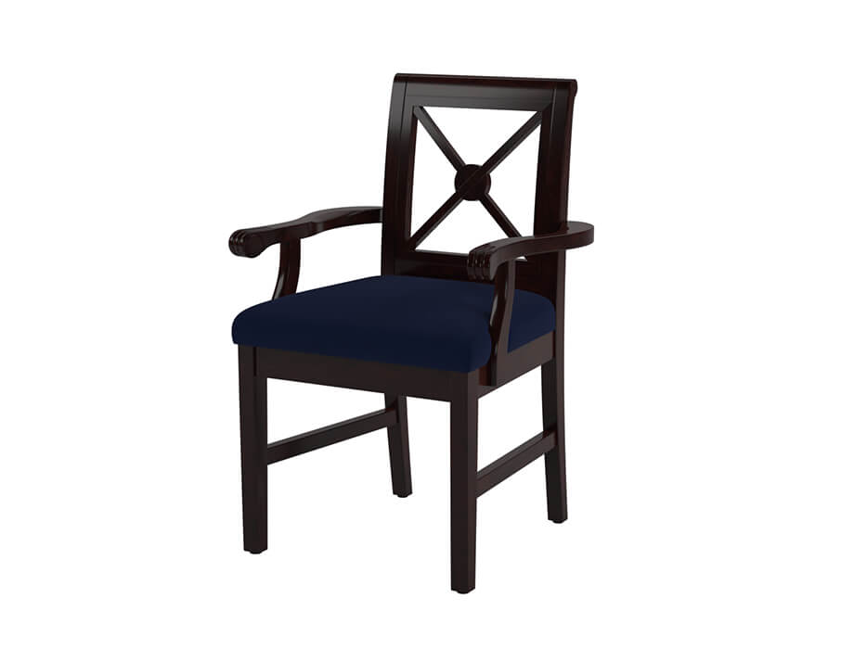 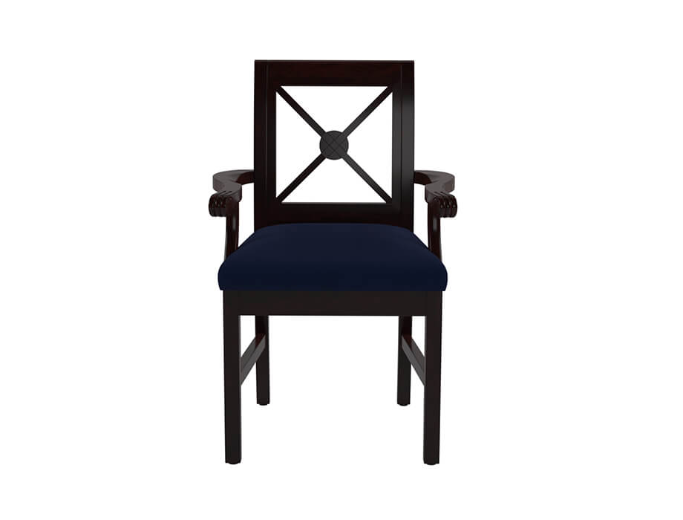

Dining Chair Kensington Arm (Hawana Walnut Finish)

PKR 25,564PKR 30,800

Design:

Kensington

Delivered in :04 - 06 Working Days

Material: Wood/Fabric

Finish: Hawana Walnut

Size:

* 590 W x 550 D x 915 H (mm)
* 23 W x 21 D x 36 H (Inches)

Note: The actual colours may vary from those shown depending on the device you are using to view the product or the angle of the item is photographed